**Explanation of ER Diagram**

**The reference ERD is designed to complete the required features only. Some relationship may be missing in the given ITP4513_1718_2018-05-20_SturctureOnly.sql file.**

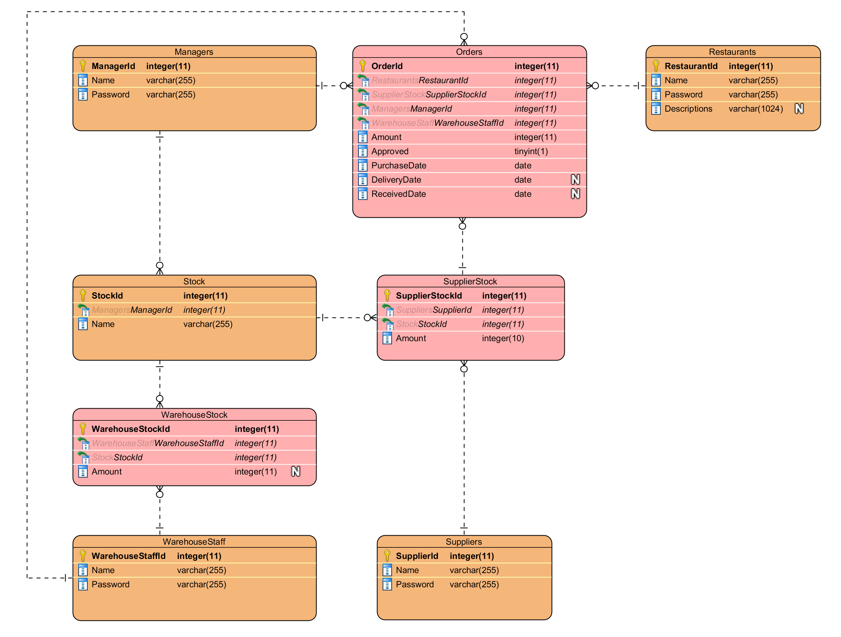

* Table Restaurants, Managers, WarehouseStaff, Suppliers store the account information of each role. Use for system login.
* Table WarehouseStock and SupplierStock represent the available stock in warehouse and able to be provided from a supplier.
* Table Stock stores the stock types. For simplification,
  + suppliers and warehouse staff only can choose the stock from the table Stock.
  + there should be no duplication of same stock type on table WarehouseStock and SupplierStock.
  + stock type only can be added by manager to the table Stock.
* Table Order store information of the order process. As all 4 roles are accessible to the ordering process, it has relationship to table Restaurants, Managers, WarehouseStaff and Suppliers.
  + Column Approved should have a false value when restaurant creates the order.
  + Column DeliveryDate and ReveivedDate are nullable as the date will be enter by supplier and warehouse staff respectively.